**LAPORAN PRAKTIKUM   
DESAIN PEMROGRAMAN WEB  
MODUL 7**

Oleh

Diki Irfandi Rosyid

19103138

**PROGRAM STUDI S1 SISTEM INFORMASI FAKULTAS INFORMATIKA**

**INSTITUT TEKNOLOGI TELKOM PURWOKERTO**

**2021**

**Pembahasan**

1. **Pengertian PHP**

* PHP merupakan singkatan dari PHP: Hypertext Preprocessor yaitu server-side
* scripting language.
* Skrip PHP dieksekusi di server dan hasilnya dikirimkan ke client (browser).
* PHP mendukung berbagai jenis database.
* (contoh : MySQL, Informix, Oracle, Sybase, Solid, PostgreSQL, Generic
* ODBC, dll.)
* PHP merupakan perangkat lunak open source.
* PHP dapat di-download dan digunakan secara gratis.

1. **File PHP**

* File PHP dapat terdiri dari teks, tag dan skrip HTML.
* File PHP akan dikirimkan ke browser sebagai plain HTML.
* File PHP dapat berektensi “.php”, “.php3”, atau “.phtml”

1. **Alasan Menggunakan PHP**

* PHP dapat berjalan pada bermacam platforms (Windows, Linux, Unix, dll.).
* PHP kompatibel (mampu bekerja) dengan hampir semua server web yang ada (Apache, IIS, etc.).
* PHP dapat di-download secara gratis dari situs resminya: www.php.net
* PHP mudah dipelajari dan berjalan secara efisien di server web.

**Praktikum**

1. **Mulai Proyek Satu**

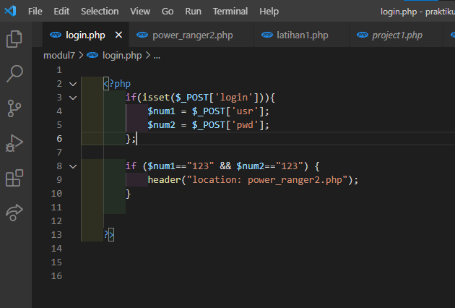

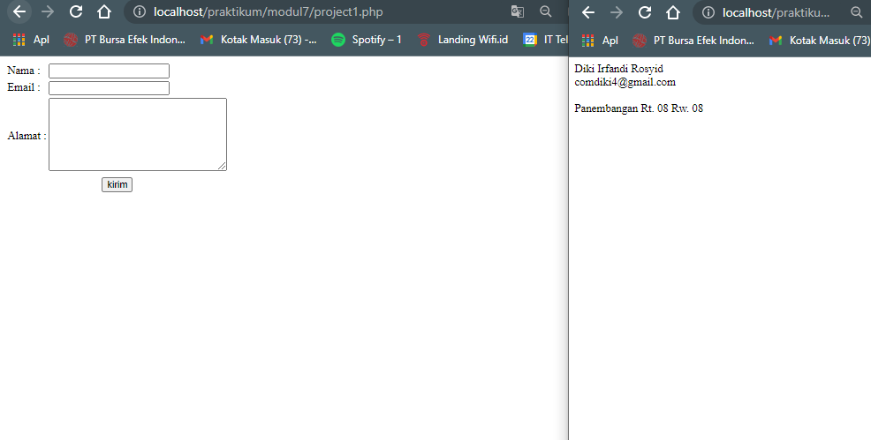

1. **Latihan satu**

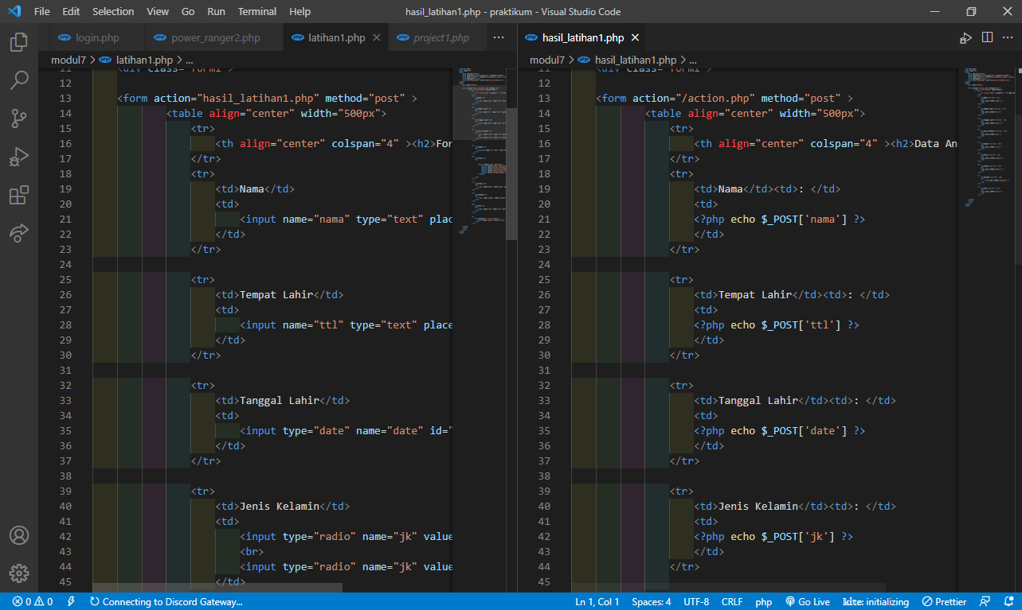

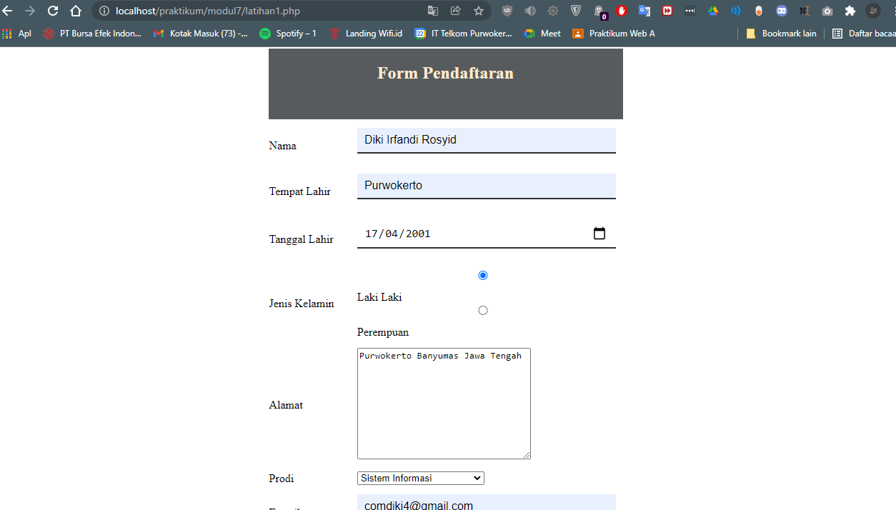

1. **Proyek Kalkulator**

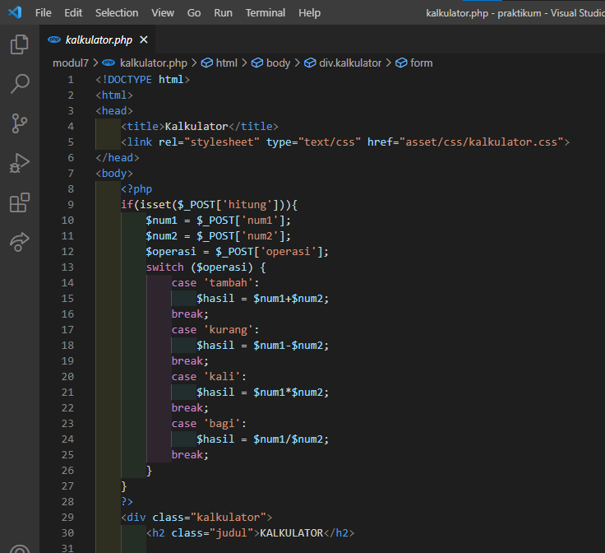

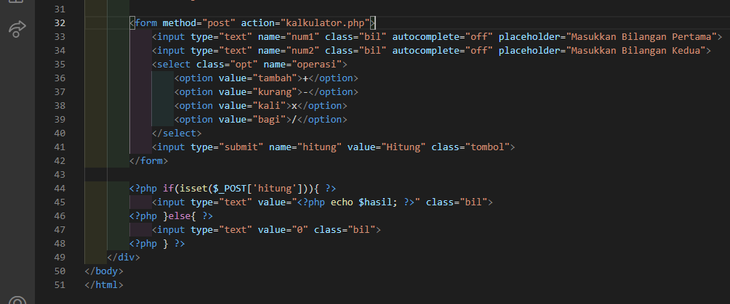

**CSS:**

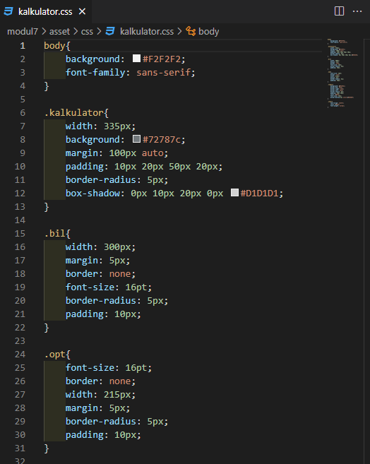

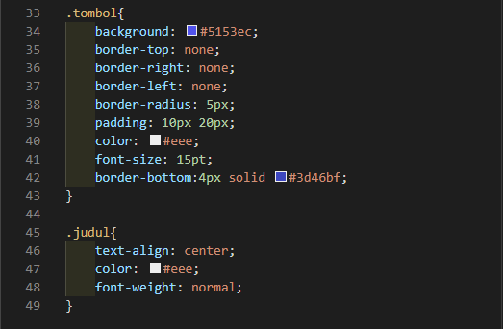

**Hasil:**

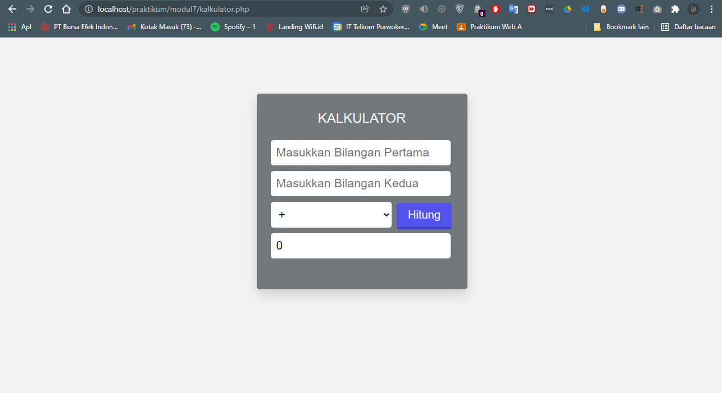

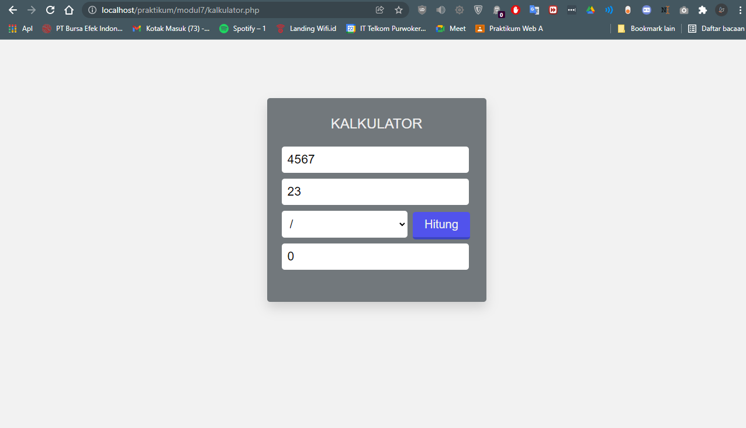

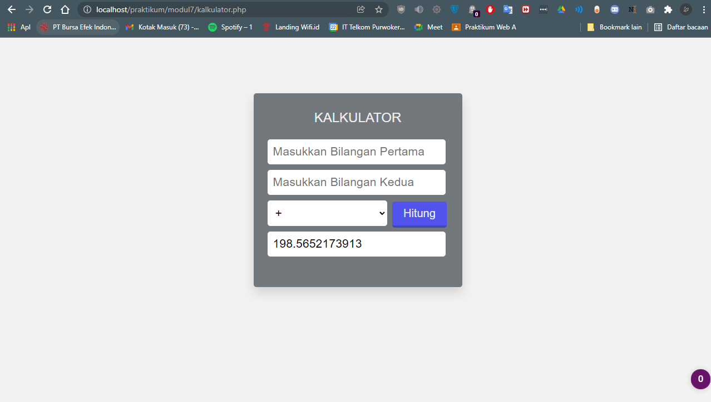

1. **Power Ranger**

**power_ranger.php**

<!DOCTYPE HTML>

<html>

    <head>

        <title>Halaman Login</title>

        <link rel="stylesheet" href="asset/css/ranger.css">

    </head>

    <body>

        <div class="container">

        <h1>Login</h1>

        <form action="login.php" method="post" >

        <label>Username</label><br>

                <input type="text" name="usr"><br>

                <label>Password</label><br>

                <input type="password" name="pwd"><br>

                <input type="submit" value="login" name="login">

            </form>

        </div>

    </body>

</html>

**Login.php**

    <?php

        if(isset($_POST['login'])){

            $num1 = $_POST['usr'];

            $num2 = $_POST['pwd'];

        };

        if ($num1=="123" && $num2=="123") {

            header("location: power_ranger2.php");

        }

    ?>

**Power_ranger2.php**

<!DOCTYPE HTML>

<html>

    <head>

        <title>Halaman Login</title>

        <link rel="stylesheet" href="asset/css/ranger.css">

    </head>

    <?php

    ?>

    <body>

        <div class="container">

          <h1>Login</h1>

          <form action="regis.php" method="post" >

            <label>Nama</label><br>

                <input type="text" name="nama"><br>

            <label>Usia</label><br>

                <input type="text" name="usia"><br>

            <label>gender</label>

                <!-- <input type="radio" name="jk" value="1" class="jk"><label for="perempuan">Perempuan</label>

                <input type="radio" name="jk" value="2" class="jk"><label for="lakilaki">Laki-Laki</label> -->

                <select name="jk" id="" class="jk">

                    <option value="1"><label for="perempuan">Perempuan</label></option>

                    <option value="2"><label for="lakilaki">Laki-Laki</label></option>

                </select>

                <input type="submit" value="login">

            </form>

        </div>

    </body>

</html>

**Regis.php**

    <?php

        if ($jk = $_POST["jk"] == '1' ){

            header("location: rangergirl.php");

          }else{

            header("location: rangerboy.php");

          }

    ?>

**rangerboy.php**

<!DOCTYPE HTML>

<html>

    <style>

        body{

            background-color: blanchedalmond;

            font-family: sans-serif;

        }

    </style>

<head>

</head>

<body>

    <div class="container" style="width: 70%; margin: auto; padding-top: 10rem;">

        <?php

        $team = $color = $weapon ="";

        if ($_SERVER["REQUEST_METHOD"] == "POST") {

        $team = $_POST["team"];

        $color = $_POST["color"];

        $weapon = $_POST["weapon"];

        }

        // $nama=$_POST["nama"];

        // $usia=$_POST["usia"];

        ?>

        <form method="post" style="text-align: left;" action="<?php echo($_SERVER["PHP_SELF"]);?>">

            Pilih Team:

            <input type="radio" name="team" value="t1">1

            <input type="radio" name="team" value="t2">2

            <input type="radio" name="team" value="t3">3<br><br>

            Pilih Warna:

            <input type="radio" name="color" value="Merah">Merah

            <input type="radio" name="color" value="Hijau">Hijau

            <input type="radio" name="color" value="Biru">Biru

            <input type="radio" name="color" value="Hitam">Hitam<br><br>

            Pilih Senjata:

            <input type="radio" name="weapon" value="Mpon  mpon">Mpon  mpon

            <input type="radio" name="weapon" value="Keris">Keris

            <input type="radio" name="weapon" value="Gada rujak polo">Gada rujak polo

            <br><br>

            <input type="submit" name="submit"><br><br>

        </form>

        <hr>

        <?php

        echo "<p>Output to Server:<p>";

        // echo "Nama ="; echo $nama; echo "<br>";

        // echo "Usia ="; echo $usia; echo "<br>";

        echo "Team = "; echo $team; echo "<br>";

        echo "Color = "; echo $color; echo "<br>";

        echo "Weapon = "; echo $weapon;

        ?>

        <hr>

    </div>

</body>

</html>

**rangergirl.php**

<!DOCTYPE HTML>

<html>

<style>

        body{

            background-color: blanchedalmond;

            font-family: sans-serif;

        }

    </style>

<head>

</head>

<body>

    <div class="container" style="width: 70%; margin: auto; padding-top: 10rem;">

        <?php

        // define variables and set to empty values

        $team = $color = $weapon = "";

        if ($_SERVER["REQUEST_METHOD"] == "POST") {

        $team = $_POST["team"];

        $color = $_POST["color"];

        $weapon = $_POST["weapon"];

        }

        ?>

        <form method="post" style="text-align: left;" action="<?php echo($_SERVER["PHP_SELF"]);?>">

            Pilih Team:

            <input type="radio" name="team" value="t1">1

            <input type="radio" name="team" value="t2">2

            <input type="radio" name="team" value="t3">3<br><br>

            Pilih Warna:

            <input type="radio" name="color" value="Pink">Pink<br><br>

            Pilih Senjata:

            <input type="radio" name="weapon" value="w1">1 Mpon  mpon

            <input type="radio" name="weapon" value="w2">2 Keris

            <input type="radio" name="weapon" value="w3">3 Gada rujak polo

            <br><br>

            <input type="submit" name="submit"><br><br>

        </form>

        <hr>

        <?php

        echo "<p>Output to Server:<p>";

        echo "Team = "; echo $team; echo "<br>";

        echo "Color = "; echo $color; echo "<br>";

        echo "Weapon = "; echo $weapon;

        ?>

        <hr>

    </div>

</body>

</html>

**Hasil**

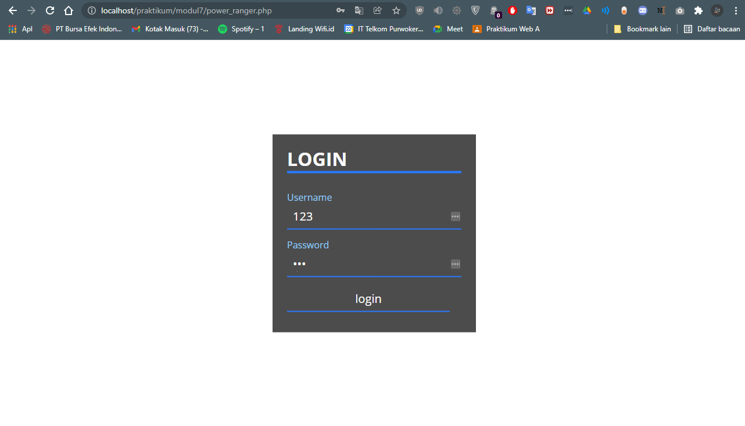

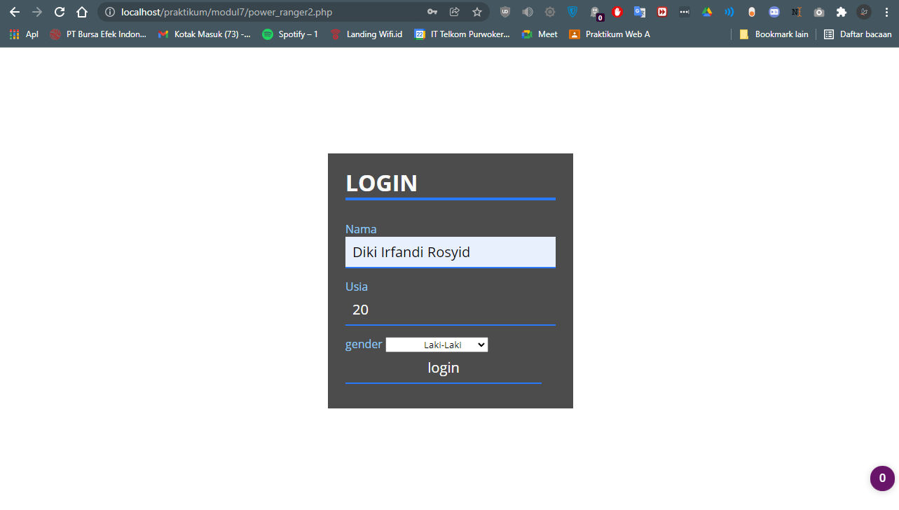

**Ranger boy:**

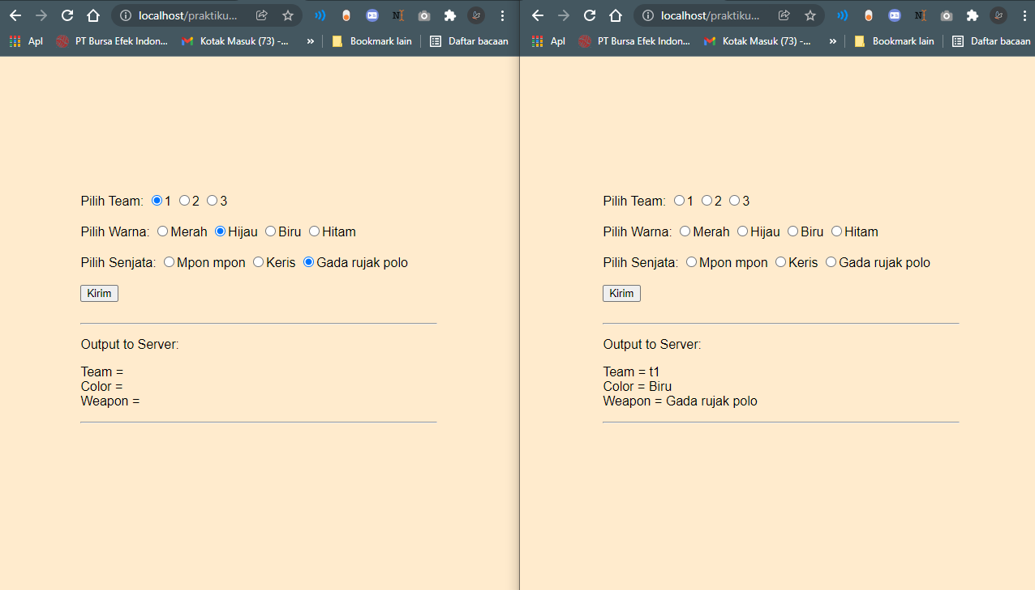

**Ranger Girl**

